NORTH-WEST UNIVERSITY
MAHIKENG CAMPUS
CMPG 325 — COMPUTER NETWORKS
INDIVIDUAL SEMESTER PROJECT

MILESTONE 1: CLIENT DESIGN REVIEW

Project ID | CMPG325-2026-075
Client ID | CI-075
Assigned Organisation | Mammonto Building Projects (Taung)
Industry | Construction
Student Number | 42090474
Student Name | TSHEPO MNGOMEZULU

Submission component: Client Requirements, Physical Topology, Logical Topology,
IP Addressing Plan and Initial GitHub Repository

1. Introduction
This document presents the initial network design for Mammonto Building Projects (Taung) as required for Milestone 1 of the CMPG 325 individual semester project. The purpose of this milestone is to review the client's requirements and establish a network design that can be implemented and extended in the later stages of the project.
The design uses the addressing block 10.32.0.0/16 supplied in the project brief. The main technical challenge is Wireless LAN integration and coverage. The design also takes account of the heritage-listed building restriction, which does not allow new cabling through external walls.

2. Client Requirements

2.1 Confirmed requirements from the project brief
- The network is being designed for Mammonto Building Projects (Taung), a construction organisation.
- The network is implemented and simulated using Cisco Packet Tracer.
- The assigned IPv4 addressing block is 10.32.0.0/16.
- The assigned networking challenge is Wireless LAN (AP integration and coverage).
- The building is heritage-listed, therefore no new cabling may be installed through external walls.
- The network accommodates the client change request involving eight additional staff members in one department.
- The design provides the additional capacity without requiring a complete network redesign.
- Connectivity and the assigned wireless challenge are tested, with evidence of successful operation captured as part of the project.
- The working Packet Tracer file and supporting evidence form part of the project portfolio.

2.2 Network design objectives
- The design provides reliable wired connectivity for the organisation's network devices.
- The design provides suitable wireless access for staff and mobile devices.
- Network functions are separated logically to support easier management and expansion.
- The IP addressing structure provides room for future growth.
- The design avoids unnecessary cabling changes that would conflict with the heritage-building restriction.
- The design is structured to support implementation and troubleshooting in Cisco Packet Tracer.
- The design allows the eight additional staff members to be added to their department without changing the overall network structure.

2.3 Design assumptions for Milestone 1
The project brief does not list every department, workstation count or network service. For this initial design, the following working assumptions are used and remain subject to confirmed client or lecturer requirements.
- Administration will be treated as one user group.
- Project/Technical staff will be treated as a separate user group because this is a construction organisation.
- Finance/Support will be treated as a separate user group.
- Staff wireless access will be provided as a dedicated logical network.
- A small management network will be reserved for network infrastructure.
- The Project/Technical department is the intended department for the eight-staff growth scenario because it is a reasonable department in which additional project staff may be required. This assumption can be changed if the official client information identifies another department.

3. Physical Topology
The physical topology is represented in Cisco Packet Tracer. The main physical components are an edge router, a main switch, an access switch, wireless access points, end-user devices and a shared server or service device where required. The number of end devices is based on the available client requirements.
The physical arrangement below represents the network topology for Mammonto Building Projects (Taung).
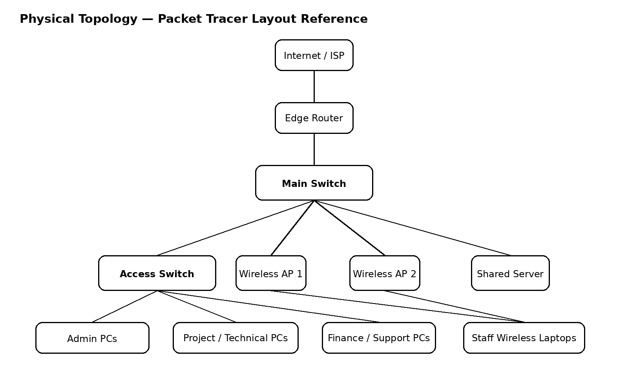

3.1 Physical design decisions
- The router provides the connection to the outside network and can also provide routing between the internal VLANs where appropriate.
- The main switch acts as the central connection point for the internal network.
- An access switch is included to provide additional wired ports without changing the overall design.
- Wireless access points are positioned so that staff devices can connect without requiring new cabling through external walls.
- End-user devices are grouped according to their departments rather than being placed randomly.
- The topology leaves spare switch capacity so that additional users can be connected later.

4. Logical Topology
The logical design separates different network functions into VLANs and IP subnets. This improves organisation, makes troubleshooting easier and provides room for future growth. The VLAN structure forms the logical network design for Milestone 1 and provides the basis for implementation and testing in the later stages.
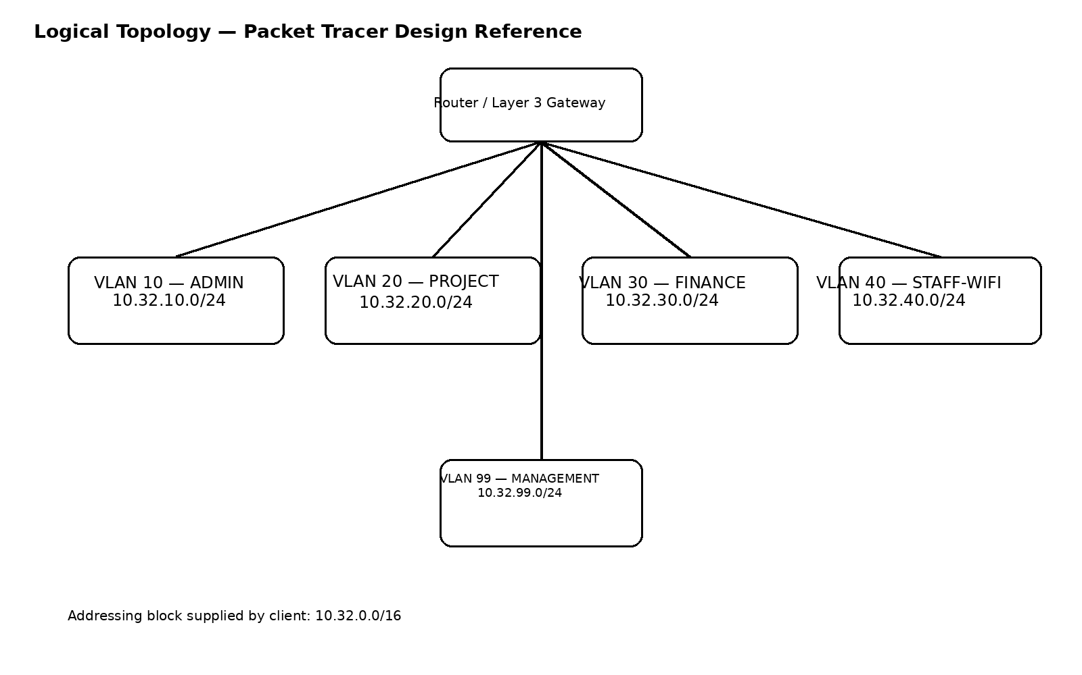

4.1 Proposed VLAN structure
VLAN | Name | Purpose | Initial Subnet
10 | ADMIN | Administration users and devices | 10.32.10.0/24
20 | PROJECT | Project / technical staff | 10.32.20.0/24
30 | FINANCE | Finance / support users | 10.32.30.0/24
40 | STAFF-WIFI | Staff wireless clients | 10.32.40.0/24
99 | MANAGEMENT | Management of network infrastructure | 10.32.99.0/24

4.2 Why VLANs are being used
- VLANs allow departments to be separated logically while still using the same physical switching infrastructure.
- The separation reduces unnecessary broadcast traffic between unrelated groups.
- The structure makes it easier to apply different access or security rules later.
- The design supports future growth because new devices can be added to an existing department network without changing the entire topology.
- The wireless network can be managed as its own logical segment while still using the same physical infrastructure.

5. IP Addressing Plan
The client-assigned address block is 10.32.0.0/16. A /24 subnet is proposed for each main logical network in the initial design. A /24 provides 254 usable host addresses, which is more than the expected initial number of devices and leaves sufficient space for growth, including the eight additional staff members.
VLAN | Network | Mask | Gateway | Usable Host Range | Broadcast | Purpose | Growth
10 | 10.32.10.0/24 | 255.255.255.0 | 10.32.10.1 | 10.32.10.2–10.32.10.254 | 10.32.10.255 | Administration | High
20 | 10.32.20.0/24 | 255.255.255.0 | 10.32.20.1 | 10.32.20.2–10.32.20.254 | 10.32.20.255 | Project / Technical | High
30 | 10.32.30.0/24 | 255.255.255.0 | 10.32.30.1 | 10.32.30.2–10.32.30.254 | 10.32.30.255 | Finance / Support | High
40 | 10.32.40.0/24 | 255.255.255.0 | 10.32.40.1 | 10.32.40.2–10.32.40.254 | 10.32.40.255 | Staff Wireless | High
99 | 10.32.99.0/24 | 255.255.255.0 | 10.32.99.1 | 10.32.99.2–10.32.99.254 | 10.32.99.255 | Infrastructure Management | High

5.1 Address allocation approach
- The default gateway for each VLAN is the first usable address in that subnet.
- Network infrastructure addresses can be reserved from the beginning of the relevant subnet.
- End-user devices can receive addresses through DHCP during implementation, while selected infrastructure devices can use static addresses.
- The unused portions of the 10.32.0.0/16 block remain available for future networks, additional sites, or further segmentation if the client later requires it.
- The Project/Technical subnet is intentionally much larger than the immediate requirement so that eight additional staff members can be added without changing the subnet.

6. Client Change Request: Eight Additional Staff
The client has requested eight additional staff members in one department. The design addresses this requirement by reserving enough host capacity in the department subnet from the beginning. The Project/Technical department is currently allocated 10.32.20.0/24, which provides 254 usable addresses.
Therefore, adding eight staff members does not require a new subnet, a new router, or a complete topology redesign. New user devices can be connected to the existing access layer and assigned to VLAN 20. If wireless access is required, the same staff can be connected through the planned wireless infrastructure.

7. Wireless LAN Challenge
Wireless LAN integration and coverage is the assigned networking challenge for this project. The wireless design will therefore be tested rather than only shown on the diagram.
- Access points are positioned in suitable internal locations in the Packet Tracer physical layout.
- The access points connect to the switching infrastructure without requiring cabling through external walls.
- The wireless network uses the planned staff wireless addressing.
- Laptops and other wireless clients receive IP configuration from the designated staff wireless network.
- Wireless client connectivity to the appropriate internal network resources is included in the testing plan.
- Wireless coverage and configuration issues encountered during implementation are documented together with their resolutions.
- Packet Tracer simulation and connectivity tests provide evidence of successful wireless operation.

8. Initial Testing Plan
Test | Expected result | Evidence | Stage
PC to default gateway | Successful ping | Packet Tracer ping result | Milestone 2
PC to PC within same VLAN | Successful connectivity | Ping / simulation result | Milestone 2
Inter-VLAN connectivity | Successful where permitted | Ping / routing verification | Milestone 2
Wireless client obtains IP | Correct VLAN/subnet address | IP configuration screenshot | Milestone 2
Wireless client to internal resource | Successful connectivity | Ping / simulation result | Milestone 2
Eight additional staff | All added devices have addresses and connectivity | Updated Packet Tracer evidence | Final/change request

9. Packet Tracer Implementation Overview
The implementation maintains the same network structure established in this milestone. The final device count is based on the confirmed client requirements.
- The network project is implemented and simulated using Cisco Packet Tracer.
- The network includes one edge router and one main switch.
- An access switch provides additional connections for end-user devices.
- Wireless access points are positioned within the internal building areas to provide staff wireless coverage.
- Representative PCs and laptops are included for each department together with wireless client devices.
- The logical network uses VLANs 10, 20, 30, 40 and 99.
- Switch ports are associated with the appropriate VLANs, with trunking used where required.
- The router or Layer 3 gateway provides routing for the VLAN networks.
- The IP addressing and DHCP plan follows the addressing structure defined in this milestone.
- The wireless network provides connectivity for the designated staff wireless clients.
- Connectivity is evaluated using the tests specified in the Initial Testing Plan.
- The working Packet Tracer file and supporting evidence form part of the project portfolio.

10. Initial GitHub Repository
The GitHub repository serves as the working portfolio for the Mammonto Building Projects network project. It contains the Milestone 1 design documentation and the project structure for the Milestone 2 implementation and final submission. The same project is maintained throughout the different project stages.
CMPG325-2026-075/
├── README.md
├── Milestone-1/
│ ├── Client-Requirements/
│ ├── Physical-Topology/
│ ├── Logical-Topology/
│ └── IP-Addressing-Plan/
├── Milestone-2/
├── Packet-Tracer/
├── Evidence/
├── Troubleshooting/
└── Final/

10.1 Initial README content
The README identifies the project, client, addressing block, assigned networking challenge, design constraint and purpose of the repository. Project information is maintained as the project develops.

11. Milestone 1 Boundary
This milestone establishes the initial network design. The physical and logical topologies, addressing plan and requirements provide the foundation for the Milestone 2 implementation. Configuration details, full testing, troubleshooting evidence, the final change request implementation and the individual video demonstration form part of the later project stages.

12. Conclusion
The proposed design uses the client-assigned 10.32.0.0/16 address block and separates the main network functions into logical VLANs. The design gives the organisation room for growth and specifically provides capacity for the requested eight additional staff members. Wireless access is included as a central part of the design because it is the assigned networking challenge, while the heritage-listed building restriction is considered in the physical layout.
The working assumptions in this document form the basis of the initial design and remain subject to any additional confirmed client or lecturer requirements. Any confirmed requirements will be incorporated into the Packet Tracer topology and addressing plan to maintain consistency throughout the project.
GitHub Link: https://github.com/Tshepomngomezulu2/CMPG325-Network-Design-Mammonto-Building-Projects-Taung

